Thank you for downloading our Teach Your Monster to Read editable word posters!

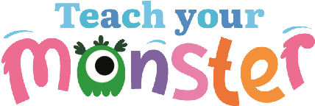These cute and kooky posters will help you highlight and remind your kids of words they should be using.  
  
To edit and add your own word, double-click the ‘word’ text box on each of the monsters below.   
  
  
**Teacher Tip: Rotate your high frequency words with other class teachers to save on time and resources!**

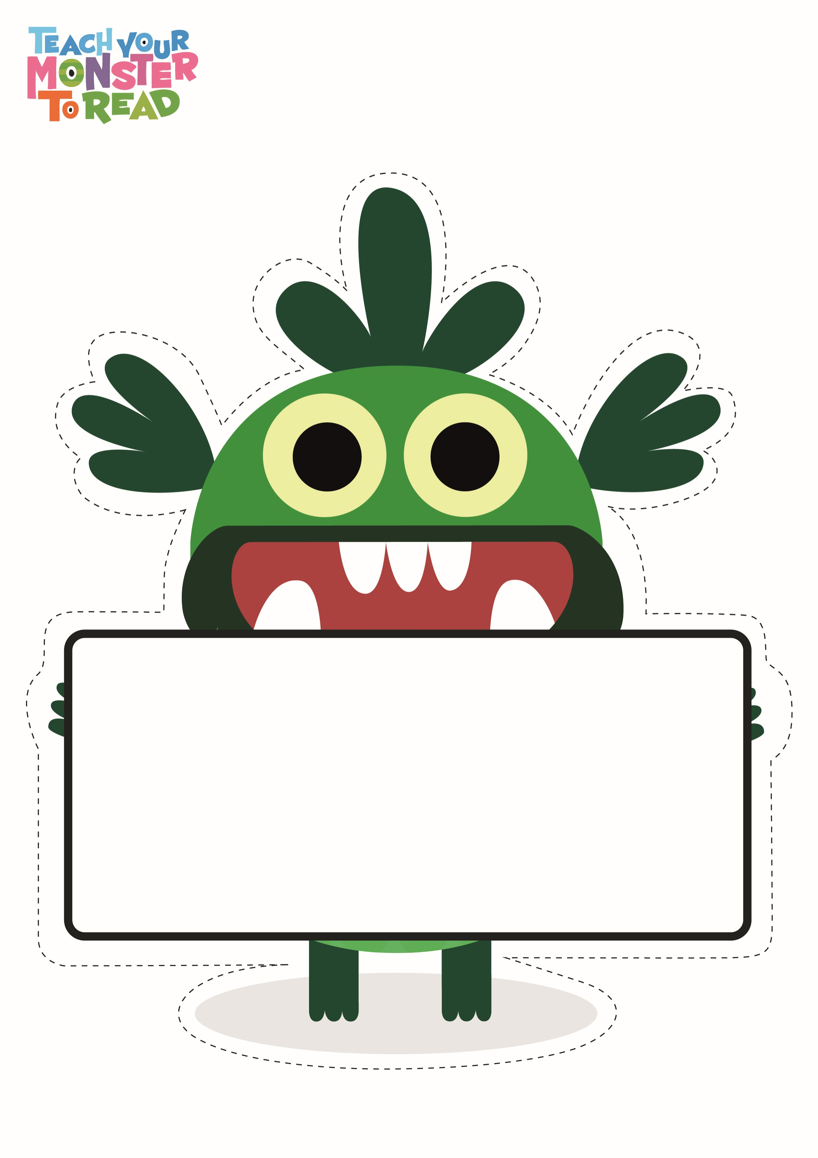

word

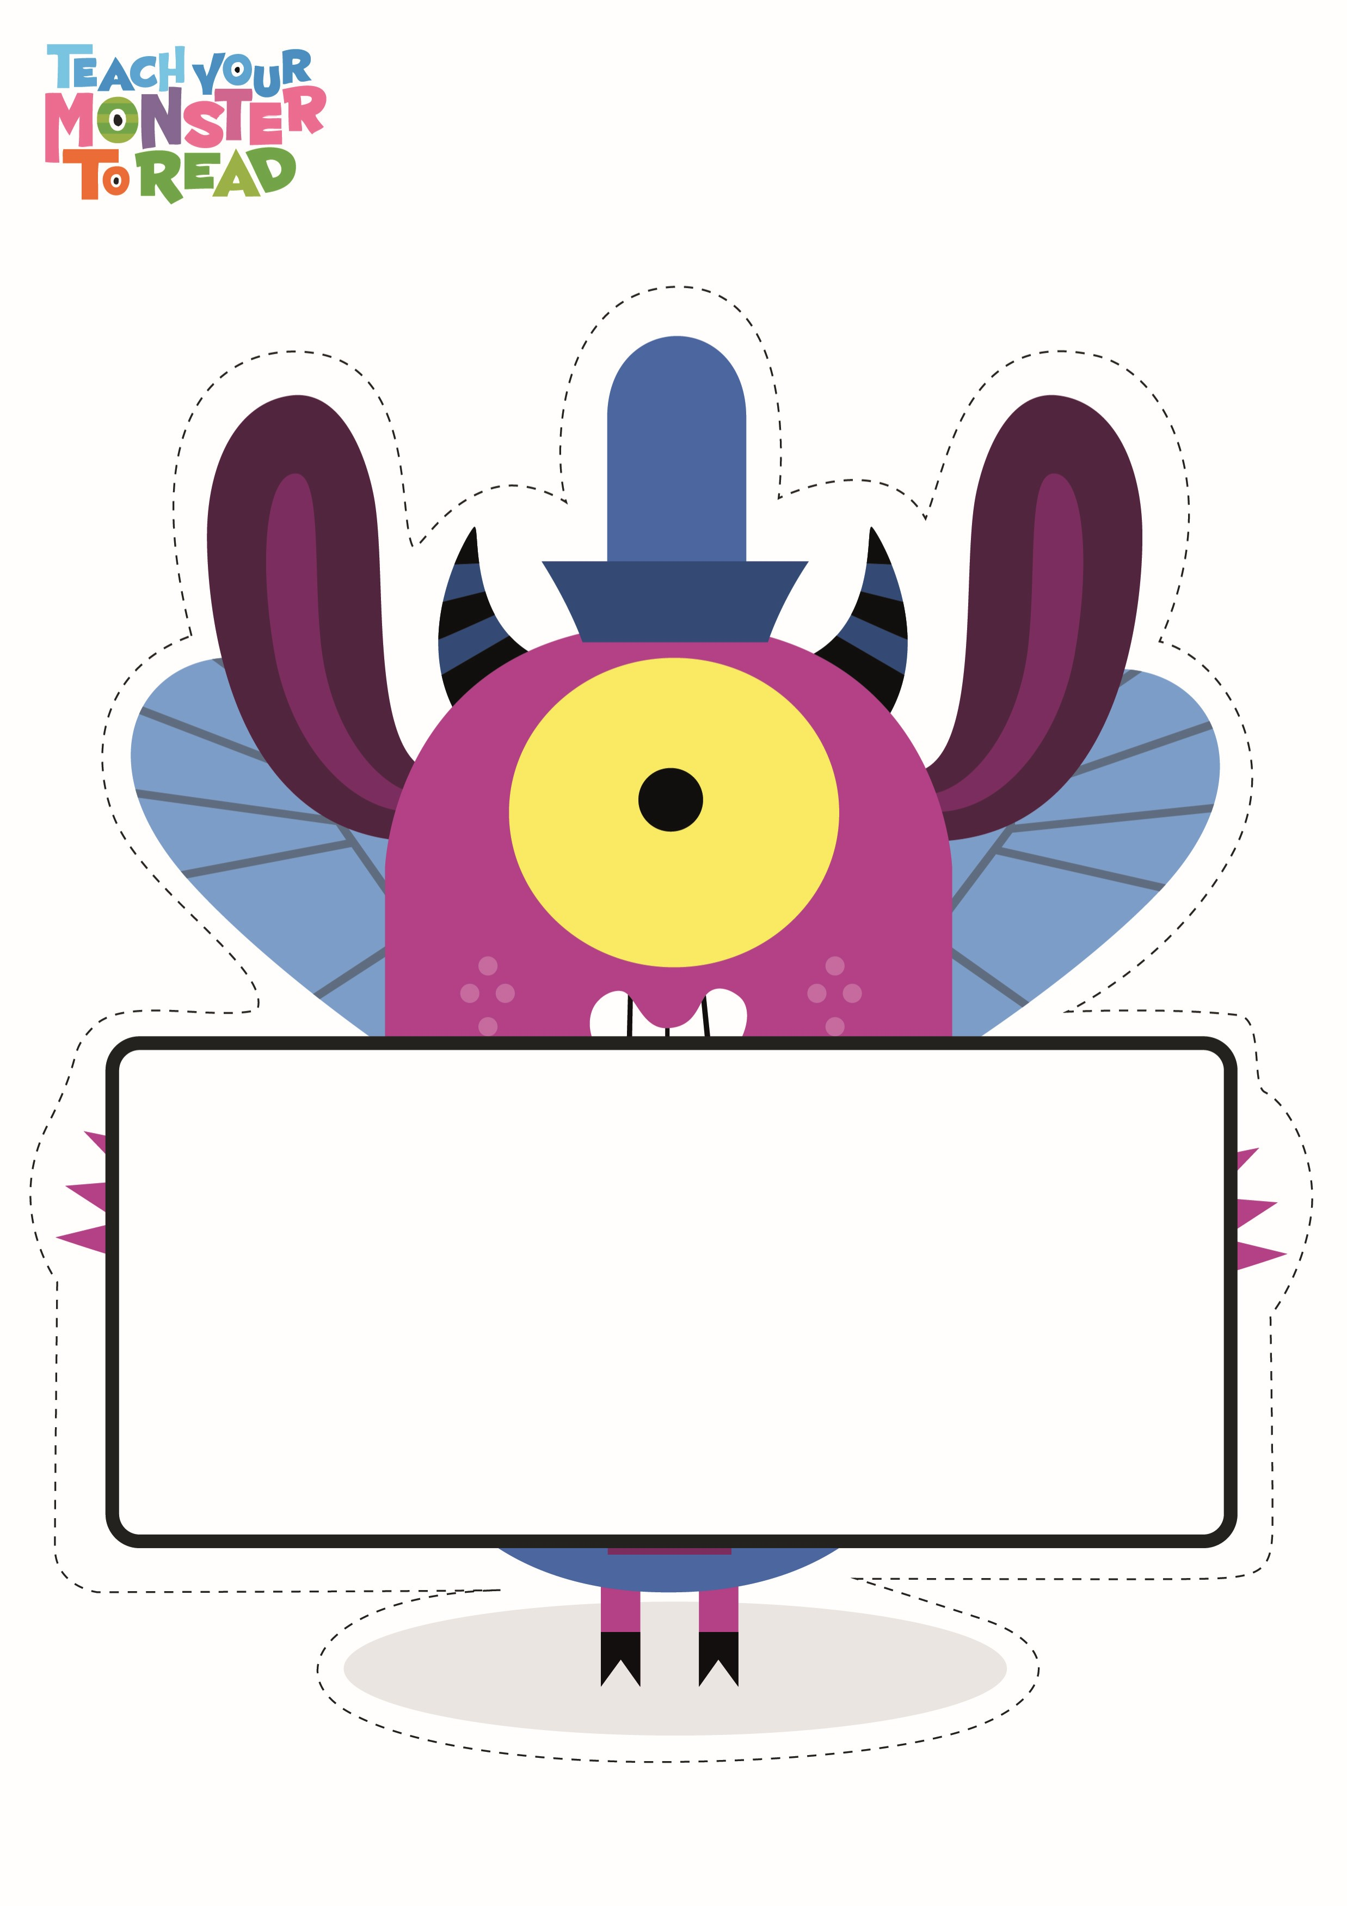

word

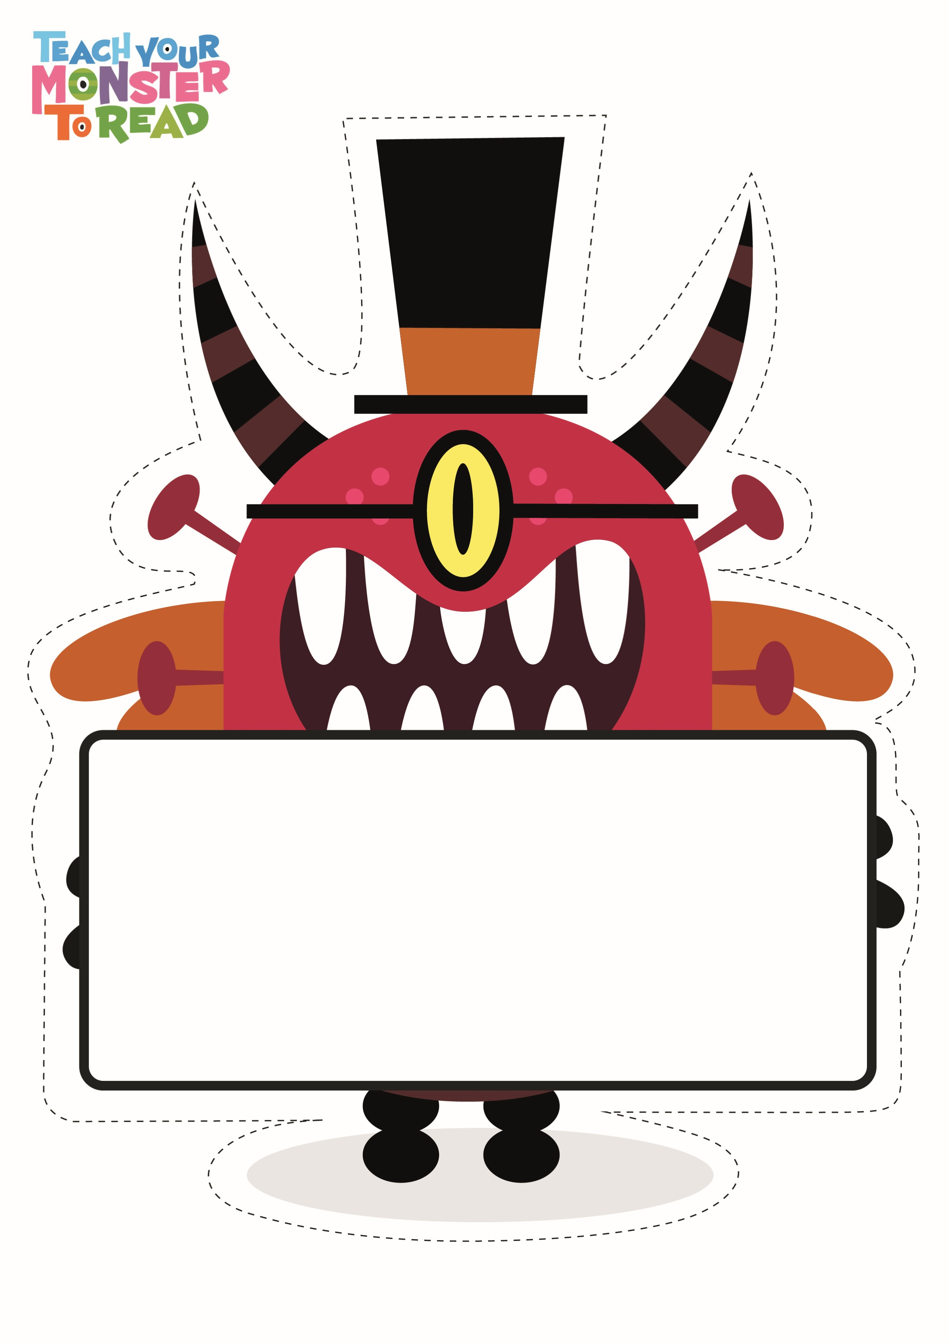

word

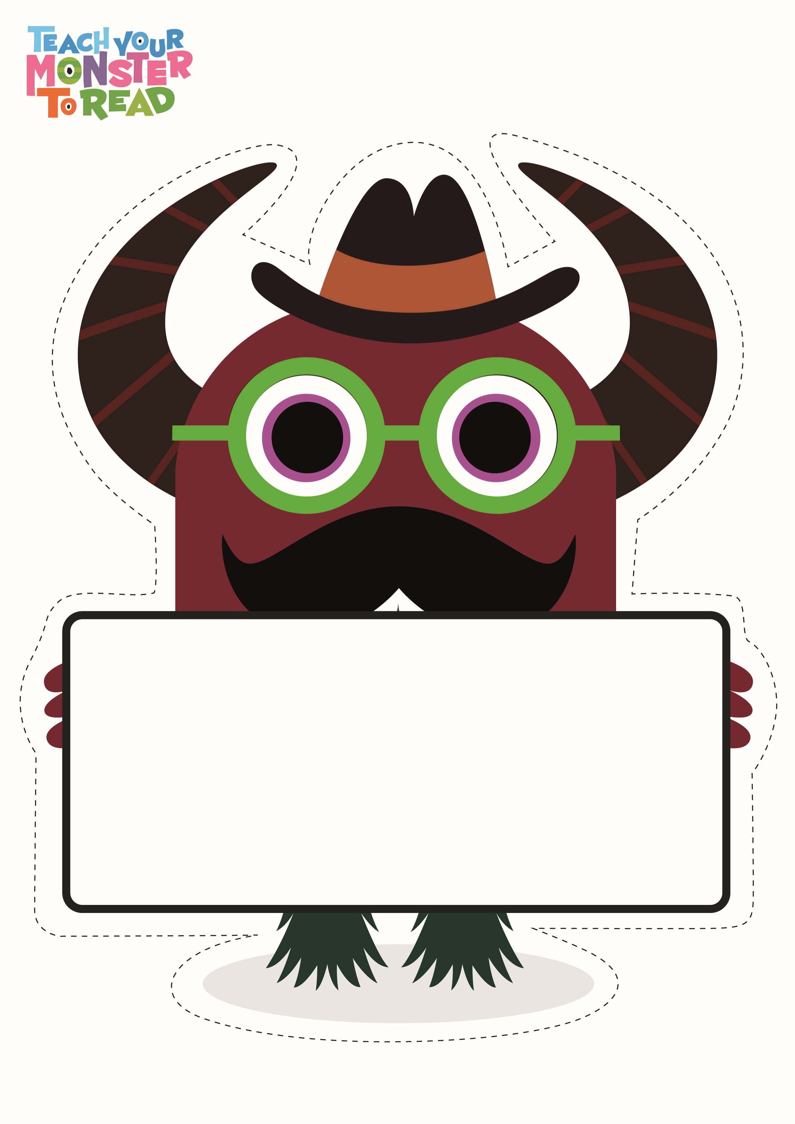

word

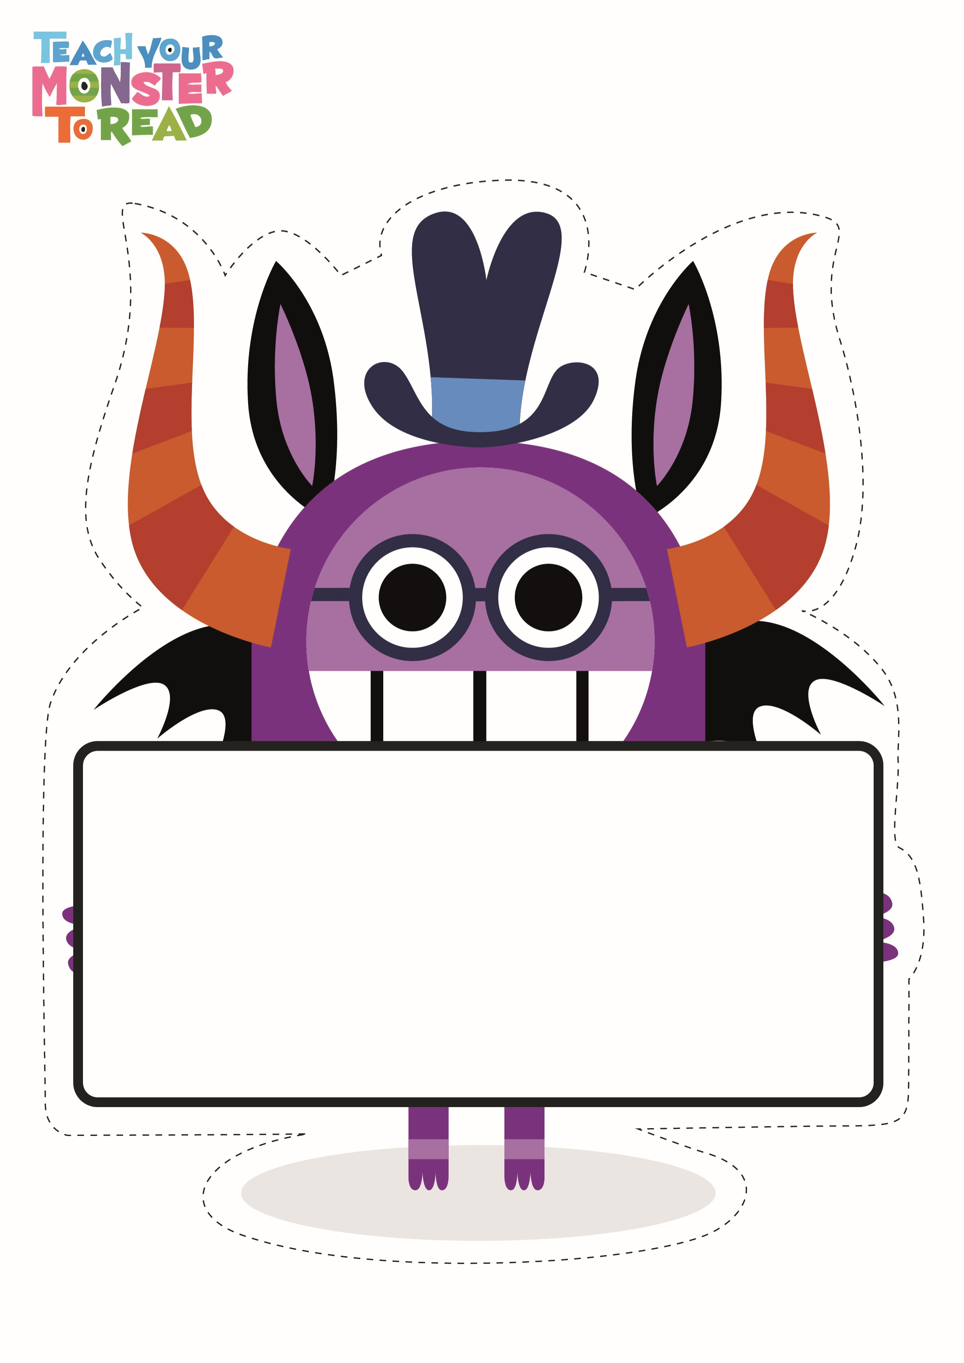

word