Hi there,

Teach your Monster to Read is an award-winning series of games which help children to master the key first stages of reading. It’s been created by the Usborne Foundation, led by Peter Usborne (of Usborne Publishing).

We’re using it at school and your child will benefit more from the game if they can play at home.

It’s free to play on a PC and laptop at TeachYourMonsterToRead.com, or you can download the Teach Your Monster to Read app from the app store on phones and tablets.

If we’ve given you a password card (optional), then you can log in to your child’s game using these details.

Example player password card:
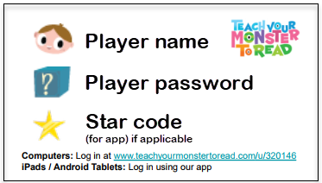

More about the game

The games develop children’s speed and accuracy of letter recognition by taking them on a fantastic adventure through magical worlds where they meet island kings and collect letters to win prizes. Children adopt and customise a monster, who they guide through the learning process.

Find out more at teachyourmonstertoread.com

All the best,

Class teacher

