Charitable Fund The Usborne Foundation launches third free online reading game
TEACH YOUR MONSTER TO READ 3: CHAMPION READER

The Usborne Foundation announces the anticipated launch of Teach Your Monster to Read 3: Champion Reader, a free online reading game to help young learners further develop their reading skills. In collaboration with reading experts at the University of Roehampton, the latest game in the BAFTA-nominated, multi-award winning series is compatible with Phase 5 of the UK Letters and Sounds programme, and other major systematic synthetic phonics programmes.

By combining the expertise of a multidisciplinary team, The Usborne Foundation has created a brand new approach to educational game development; a successful formula which really sets the standard for educational games.

With a strong focus on developing children’s skills in reading more fluently and for meaning, the new game builds on children’s existing knowledge of graphemes and phonemes, introducing new pronunciations and spellings. It also provides further blending and segmenting practice, and children gain extensive sentence practice throughout the game.

Peter Usborne, founder and managing director of Usborne Publishing who also established The Usborne Foundation, a charitable organisation, said, “Our series of Teach Your Monster to Read games support children at different reading levels, and as well as being a fun and exciting way to learn, they are also free. The games are proving an enormous hit with teachers, parents and children. It’s wonderful to take the adventure to the next level with the launch of Teach Your Monster to Read 3: Champion Reader, and to instil a sense of exploration and discovery for today’s young learners.”

Teach Your Monster to Read 3: Champion Reader, welcomes the monsters from series 1 and 2 into a new universe full of fascinating planets to explore, and curious new characters to meet. During their adventure, players collect stars and are rewarded with prizes for teaching their monster to read, and completing the quest successfully.

ENDS

New adventures, new characters, new challenges

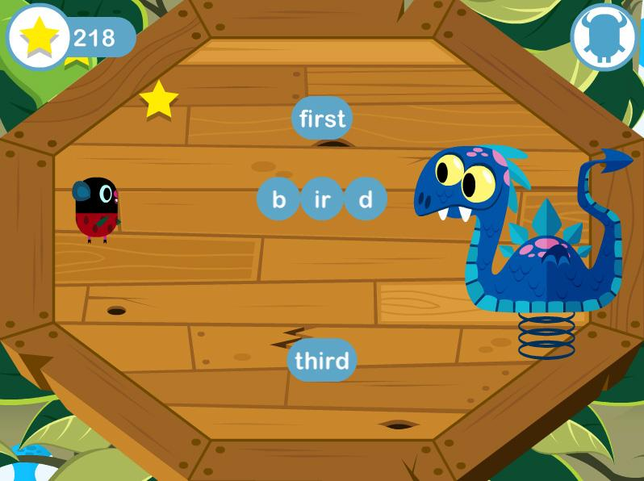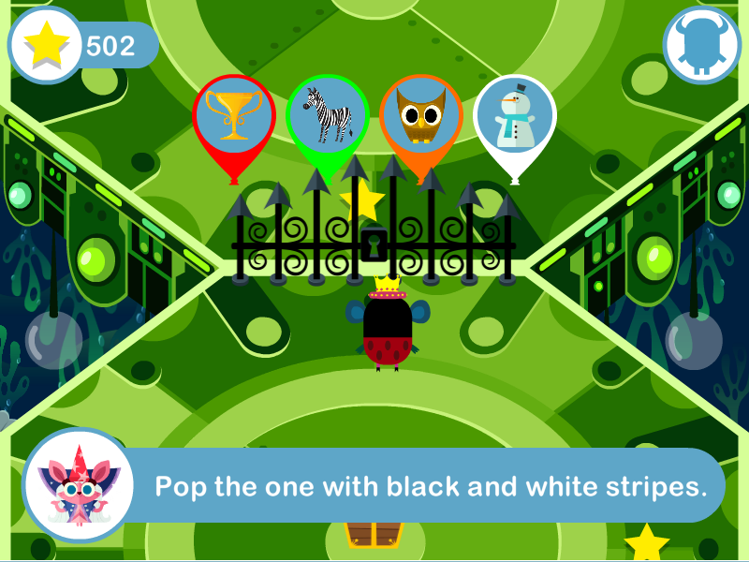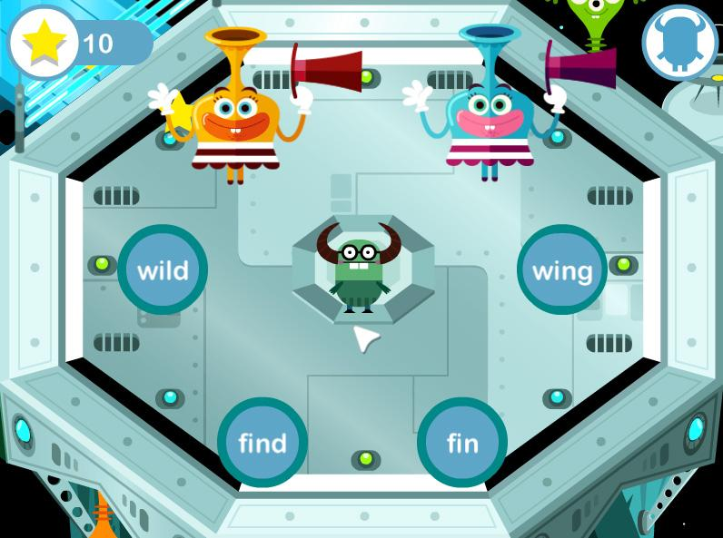
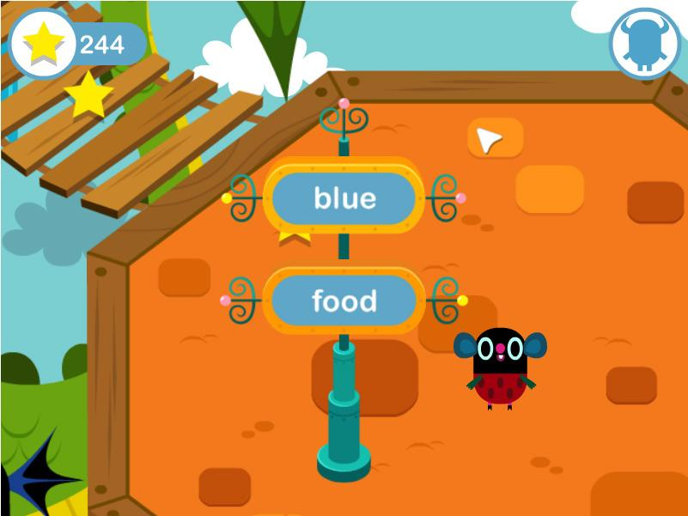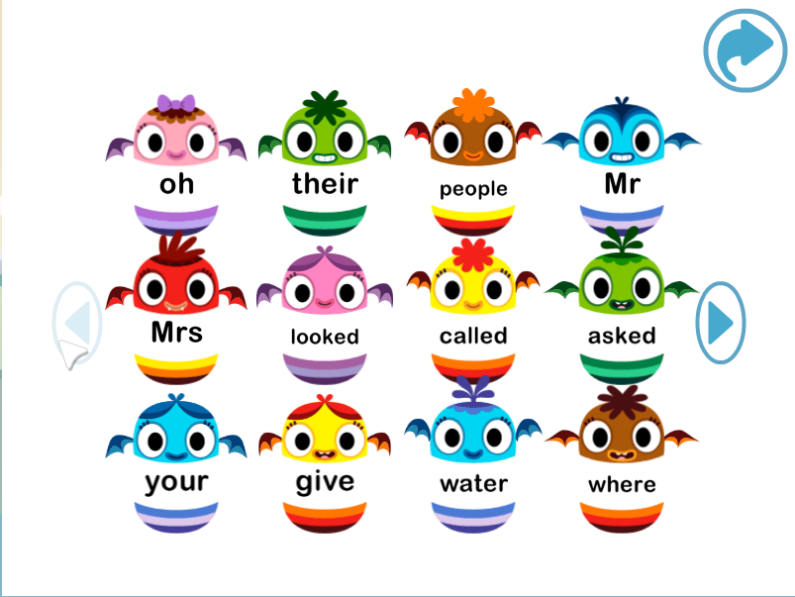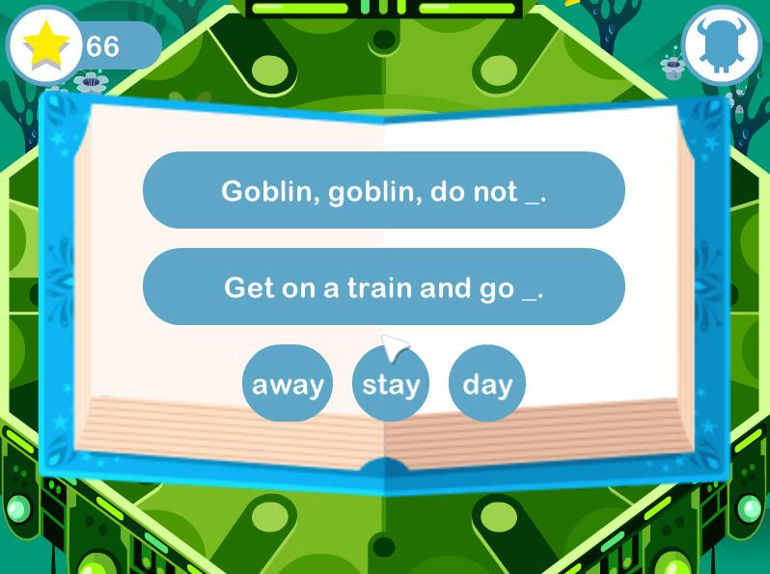

About The Usborne Foundation
The Usborne Foundation is a charitable fund established by Peter Usborne and his two children, Nicola and Martin, to support selected charities, mostly in the area of early literacy.
Peter Usborne is the founder and managing director of Usborne Publishing now one of the world's leading children's book publishing companies, which has made books for early readers one of its most important specialisations. Peter has been especially interested for a long time in finding some way of harnessing children's natural fascination with computer games to some useful purpose.
Nicola Usborne worked for many years for Scholastic Inc in New York, where she was responsible for developing an educational software program for reading for American schools, as well as a New York Times bestselling 'transmedia' book-with-online-puzzles series, The 39 Clues. Martin Usborne has undertaken extensive research on children's games for children's television programme development.

Teach Your Monster to Read
Teach Your Monster to Read is a series of three games which help children to learn the key first stages of reading, and have been designed in collaboration with leading academics from University of Roehampton.
Combining top quality game design with essential learning, the games complement most systematic synthetic phonics programmes.
The game series includes Teach Your Monster to Read: First Steps; Teach Your Monster to Read: Fun with Words; and Teach Your Monster to Read 3: Champion Reader.
For further information visit www.teachyourmonstertoread.com

Press contact:
Sarah Swain
07932 656891
Sarah.swain@mydaspr.co.uk

